Italian Cellist-Composer Riccardo Pes Plays His ‘Lament for the Tree’ at Sycamore Gap
Riccardo Pes
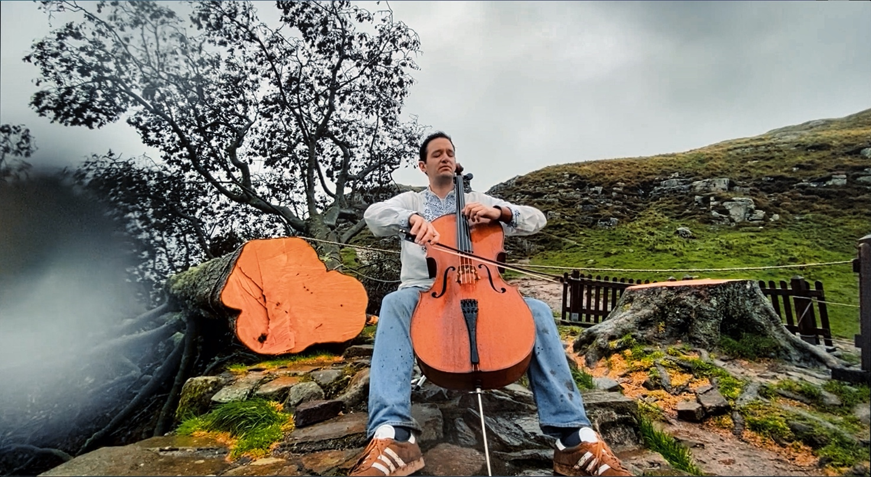

HALTWHISTLE, UK - Oct 6, 2023 The Italian cellist-composer Riccardo Pes traveled from Italy to the north of England to play his composition, ‘Lament for the Tree’, at Sycamore Gap. The beloved and world-famous tree was discovered felled on September 29, and after hearing the tragic news, Pes canceled his commitments and took the first flight to London to reach the site to pay his tribute and bid it farewell.

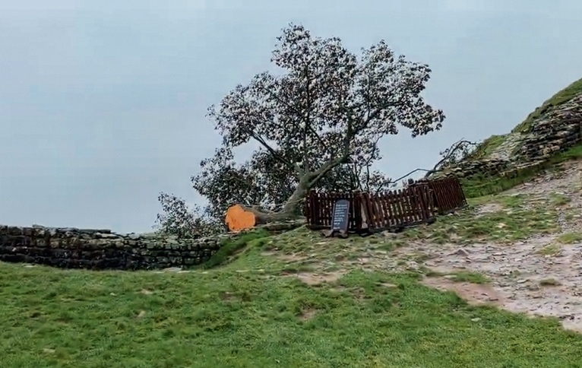
“I heard the tragic news about the loss of this incredible tree from my friend and colleague, Brenda Neece, curator of the cellomuseum.org. I was distraught; I felt as if I had lost a dear friend. I remember pictures of this special tree in my books when I studied the Roman Empire. As a cellist, I feel a strong connection with trees. Brenda suggested that I go and play for the tree. Playing the cello is my way of expressing my sorrow,” Pes said.

Pes’s original work, ‘Lament for the Tree’, is a composition inspired by the Gaelic tradition of the lament - a traditional folk song based on repetition often used to mourn loved ones, heal from tragedies, and transcend loss.

Pes’s travels with his cello to get to the tree weren’t easy. It felt like embarking on a real-life adventure and required a heavy dose of bravery. As Pes explained, “After four hours by train from London, I was so close - only an 11-minute drive from The Sill Discovery Centre, where the footpath to Sycamore Gap starts. However, due to the public transportation strike, I was stuck at Haltwhistle with no buses or taxis.” After many attempts, Fiona Forsythe, a volunteer at the tourist office, found Pes a lift to the Sill. “Yet the adventure was far from over because once I got there, I had to walk in abysmal weather conditions - through the mud - with my cello for 40 minutes. However, I have no regrets. The effort was worth it, and I will never forget this experience and the lovely people I met along the way. I also want to thank my friend and artist Deborah Schneebeli-Morrell who kindly lent her cello for this adventure,” recalled Pes. “I’m so happy I was able to document this journey on video.”

Pes is committed to combining music and nature – and to making music relevant to current environmental issues. As a composer, he has already written many compositions inspired by nature and physics. He recently published a new single, ‘Himalaya,’ and it is not unusual to see him playing a hay cello constructed entirely from grass. His commitment to the environment inspired him to found and curate the Blanc European Festival in Italy. The festival comprises a series of multi-art performances promoting a culture of respect and care for the environment through the artsz

Reporting on the performance on The Cello Museum website, curator Dr. Brenda Neece shared the idea to make cellos from the fallen tree and allow its voice to live on, even after this tragic loss.

Link to the video
Link to Riccardo’s website
Link to the Cello museum article
Link to more pictures and footages

Contact
Chantal Valdambrini
management@riccardopesmusic.it

